
VERSION NO:
1
-
3
VERSION DATE:
2003
-
10
-
29
DOCUMENT
TYPE:
Version 03
Departement
van
Waterwese
en
Bosbou
Department of Water Affairs and Forestry
Towards a Long
-
Term Strategy for Information
Systems to Support Integrated
Water Resources Management
SCOPING PHASE
VERSION NO:
1
-
3
VERSION DATE:
2003
-
10
-
29
DOCUMENT
TYPE:
Version 03
VERSION NO:

-
3
VERSION DATE:
2003
-
10
-
29
DOCUMENT
TYPE:
Version
Departement
van
Waterwese
en
Bosbou
Department of Water Affairs and Forestry
Towards a Long
-
Term Strategy for Information
Systems to Support Integrated
Water Resources Management
SCOPING PHASE

DOCUMENT HISTORY

NAME | DATE | VERSION | REASON
Lemogang Moletsane | 05-September-2003 | 01 | Draft for validation
Phephetso Mashilo | 17-October-2003 | 02 | Updated as per inputs received
Phephetso Mashilo | 29-October-2003 | 03 | Updated as per inputs received
Herman Keuris | 05 November 2003 | 04 | Final edit

DOCUMENT ACCEPTANCE

Designation | Name | Date | Signature
Producer | Phephetso Mashilo
Portfolio Manager: User Representative | Herman Keuris
Director: Information Programmes | Eberhard Braune
Chief Director: Information Management | Mbangiseni Nepfumbada
CIO | Gundo Manyatshe

TABLE OF CONTENTS

1 INTRODUCTION 5
2 EXECUTIVE SUMMARY 8
3 ABBREVIATIONS 10
4 BACKGROUND 12
5 FINDINGS 16
6 RECOMMENDATIONS 21
7 WAY FORWARD 29
ANNEXURE A: OUR UNDERSTANDING OF WRM BUSINESS 35
A.1 Context Diagram 35
A.2 LEVEL 0 - Information Flow Diagram 36
A.3 The ‘Old’ vs ‘New’ Paradigm of WRM 37
ANNEXURE B: DETAILED (INTERVIEW) REPORTS 40
B.1 WATER USE 40
B.1.1 Water Allocation 40
B.1.2 Abstraction and In-stream Use 42
B.1.3 Waster Charge and Disposal 44
B.2 STRATEGIC CO-ORDINATION 45
B.3 RESOURCE DIRECTED MEASURES 46
B.4 INSTITUTIONAL OVERSIGHT 47
B.5 INTEGRATED WR PLANNING 49
B.6 PLANNING SYSTEMS 50
B.7 INFORMATION MANAGEMENT 51
B.7.1 The Chief Directorate: Information Management. 51
B.7.2 Information Programmes 52
B.7.3 Business Information 54
B.7.4 Hydrological Information 55
B.7.5 Resource Quality Information 58
B.8 REGIONAL CO-ORDINATION 59
B.9 WESTERN CAPE REGION 60
B.10 CORPORATE / INTEGRATED INFORMATION SYSTEMS 61
B.11 DEPUTY DIRECTOR GENERAL: POLICY & REGULATION 62
B.12 CHIEF INFORMATION OFFICER 62
B.13 EASTERN CLUSTER 64
B.14 NORTHERN CLUSTER 65
B.15 CENTRAL CLUSTER 66
B.16 REGIONAL DIRECTOR: FREE STATE 67
ANNEXURE C: LIST OF KEY ROLE PLAYERS INTERVIEWED 68
ANNEXURE D: LIST OF DOCUMENTS AVAILABLE 69
ANNEXURE E: LIST OF IDENTIFIED INFORMATION SYSTEMS 71

INTRODUCTION

Purpose of this Document

The document presents the initial findings, early recommendations and the proposed way forward to achieve the objectives of the Project. It is the primary deliverable of the Scoping Phase, which is a preliminary study for the more comprehensive project: Towards a Long-Term Strategy for Information Systems to Support Integrated Water Resources Management.

This report serves as a discussion document for its intended audience who consists of four components:

- Policy & Regulation Management: | to provide support for the implementation of the urgent recommendations;
- Information Management: | for approval to implement the recommendations made and to continue with the rest of the study;
- Stakeholders: | to be used for background, comments and contributions, and
- Future project members: | to be used for background information, sources of information and guidance.

Urgent recommendations, as well as alternative ways forward to achieve the objectives of the Project are presented in this document. Some of the details are bound to change as a better understanding of these aspects develops during the course of the Project.

The document must be seen as a snapshot (through a less than perfect lens) of a significant part of the water resources management functions under Policy & Regulations and Operations. Available time and resources limited this reconnaissance to those units that are perceived to have the most significant need for information systems. The results and recommendations must therefore be seen in this light and as such, your contributions (pointing out misunderstandings, omissions and shortcomings) can contribute much to the development of these recommendations, and thus help us create a roadmap to establish the best water resources management institution in the world.

Readers are therefore requested to comment on these findings and make recommendations in order to contribute to the refinement of the proposed approach.

Goal of the Project:

The purpose of this Project is to develop a long-term strategy that will enable the Manager: Information Management to develop and maintain the sophisticated information systems and -programmes required to support monitoring, assessment and information management according to the National Water Act, as well as the coordination, support and audit of its implementation by the Department and other Water Management Institutions.

The broad scope of the Project is a study of the Water Resources Management functions in Policy & Regulations and Operations in respect of the following aspects:
- An understanding of business context, vision, objectives and critical success factors;
- The information requirements of the Water Resources Strategy for the next 20 years in support of the implementation of the National Water Resource Strategy;
- Core business processes and services in the Branches;
- Current information systems as well as the business procedures or services they aim to support;
- Identify and analyse the gaps between the business needs for information and what the existing systems plan to address in future;
- The development of a plan for the Integrated Water Resources Information Systems to bridge these gaps, and
- The presentation of the final recommendations as a Business Case to the Manager: Information Management.

Scoping Phase

Several units in the Department have already made much progress in developing strategies, programs and systems to implement measures to address their information requirements. It was therefore considered essential that the main part of the main Project be preceded by a scoping phase with the following objectives in mind:
- To introduce the project to future stakeholders;
- To understand the business environment;
- To identify and collect sources of information for the rest of the project;
- To identify high level gaps, duplications and early recommendations, and
- To plan the rest of the project.

The project team for the Scoping Phase consists of the following individuals:

Owner: Mbangiseni Nepfumbada, Manager: Information Management
User leadership: Eberhard Braune*, Manager Information Programmes*
Office of the CIO: Ernest Trenerry*
Arivia.kom : Liaane de Witt*
Project Manager: Lemo Moletsane
Business Analyst: Phephetso Mashilo
Project Support: Mametsi Ngcabo
User Representation: Herman Keuris

* Steering Committee members.

The project team has conducted 34 interviews with 46 individuals during August this year and has also had several informal discussions with other people. The team has also identified and collected a significant number of source documents.

Structure of the Report:

The report contains all the deliverables of the Scoping Phase of the project and is structured as follows:

1 | Introduction: | Purpose of the document, scope of the Project and its Scoping Phase.
2 | Executive Summary: | Provides a summary of the findings and recommendations of the Scoping Phase.
3 | Abbreviations: | List of abbreviations used in this report.
4 | Background: | Provides information on the context of the project.
5 | Findings: | Provides a structured and concise summary of the findings based on interviews, discussions and documentation.
6 | Recommendations: | Presents recommendations for urgent implementation, as well as the rest of the study.
7 | Way Forward: | Presents proposed plans for the rest of the project.
A | Understanding the environment: | Presents the project teams’ understanding of the business environment.
B | Interviews: | Structured summaries of the inputs received during the interviews.
C | List of individuals: | List of individuals interviewed.
D | Documents: | List of appropriate documents identified and/or collected as input for the rest of the project.
E | List of Systems: | Details of major information systems used in P & R

EXECUTIVE SUMMARY

Context:

A number of strong driving forces are presently acting on the management of water resources in South Africa and they make a special focus on water resources information management necessary. An Information Management component was indeed established in the Policy & Regulation Branch to give effect to the requirement of the National water Act of 1999 to ensure viable national monitoring, assessment and information systems.

The Manager: Information Management has consequently initiated the project to develop joint strategies with the stakeholders in order to address the long-term need for information and to implement the full requirements of the act. The central aim of the project is to build on the findings of previous investigations and to concentrate on the cooperation of existing initiatives, rather than the development of entirely new ones.

This report is based on the findings distilled from a series of interviews, ending into two sets of recommendations: some for immediate implementation and some to guide planning for the rest of the project.

Main Findings:

Business units were eager to participate in the investigation and have high expectations from Information Management to either directly address their information needs as a matter of urgency, or to coordinate and support their own initiatives to address their needs. The most critical areas are the following: integrating information systems, water allocation (licensing), strategic management and access to departmental data and information.

Several good and viable initiatives are already underway to address the information needs for water resources management. The big data systems are for example already supporting their respective monitoring programmes with varying degrees of success. Several analytical models and decision support systems are also already available, while a number of new ones are under development.

Unfortunately, most, if not all of these initiatives serve single functional areas while a number of the new initiatives may also attempt to address similar needs. The isolation and overlaps are probably due to insufficient coordination amongst business units as well as with Information Services.

Although all the units support the integration of information systems, they do not demonstrate sufficient understanding and support for the existing initiatives, especially in regards of funding and joint data administration, to achieve integration.

Both business and Information Services expressed their frustrations regarding the problem of insufficient resources to manage the quality of both data and infrastructure adequately.

Recommendations:

It is proposed that the following items be addressed immediately:
- Establish a proper planning cycle for information systems development and define clear roles for the various parties and business units in co-operation with Information Services, to address joint planning, budgeting and management of information projects, systems and operations.
- Implement measures to address the problems experienced in accessing information;
- Information Management to adopt the business ownership of those parts in the Corporate Integration Project which directly supports water resources management;
- The establishment of a comprehensive management information system to support the implementation and management and control of strategic plans.
- The implementation of an effective human resources strategy for the Water Resources Information Management functions.

The rest of the Project will analyse the need for information, then match them with present information programs and -systems as well as develop future strategies to bridge the existing gaps. This should be done in the following order of priorities:
- The functions related to licensing, including Resource Directed Measures and Water Use;
- Information Management, its information programs and -systems;
- The functions related to clusters, regions, future Water Management Institutions.
- The rest of the functional areas.

The recommendations conclude with a possible view of the future information architecture, flexible enough to address most configurations of functions and responsibilities amongst future Water Management Institutions. Broad five year time-steps are also suggested towards the ultimate scenario.

A last addition is a list of the most recent developments that will impact on the later phases of the Project, but surfaced to late to be assessed as part of the Scoping Phase.

Implications:

The rest of the Project will require tangible management support, adequate resources and significant dedication from the individuals involved to ensure its success.

Formal links will have to be established with Water Services, Operations, Regional Cooperation, Forestry and the Water Research Commission to find optimal solutions to problems and to implement effective information management. These measures should ensure the optimal future management of water resources.

ABBREVIATIONS
Acronym/Abbreviation | Definition
CD | Chief Director or Chief Directorate
CEIMP | Comprehensive Environmental Implementation and Management Plans
CIO | Chief Information Officer
CMA | Catchment Management Agency
DANCED | Danish Cooperation for Environment and Development
DDS | Decision Support Systems
DFID | Department of International Development of the United Kingdom
DWAF | Department of Water Affairs and Forestry
EA | Environmental Assessment
GIS | Geographical Information Systems
IM | Information Management
IP | Information Programmes
IS | Information Services
ISP | Internal Strategic Perspective
IT | Information Technology
IWRM | Integrated Water Resources Management
IWRIS | Integrated Water Resources Information Systems
IWRS | Integrated Water Resource Strategies
JAD | Joint Application Development
KFA | Key Focus Area
KPI | Key Performance Indicator
LIMS | Laboratory Information Management System
MAIS | Monitoring, Assessment and Information System
MANCO | DWAF’s Management Committee
NDMC | National Disaster Management Committee
NDMS | National Disaster Management System
NGA | National Groundwater Archive
NGIS | National Groundwater Information System
NWA | National Water Act
NWRS | National Water Resource Strategies
OPS | Operations Branch
P&R | Policy and Regulations
RDM | Resource Directed Measures
SEA | Strategic Environmental Assessment
SFRA | Stream-flow Reduction Activities
TINWA | Co-ordination Team for the Implementation of the National Water Act
ToR | Terms of Reference
WARMS | Water Administration and Registration Management System
WFSP | Water and Forestry Support Programme
WfW | Working for Water
WMI | Water Management Institution
WMS | Water Management System
WRC | Water Research Commission
WRM | Water Resource Management
WS | Water Services
WSAM | Water Situation Assessment Model
WUA | Water Use Association

BACKGROUND

The National Water Act:

The key driver for a new information management strategy is stated in the three parts of chapter 14 of the NWA (1998):

“Monitoring, recording, assessing and disseminating information on water resources is critically important for achieving the objectives of the Act. Part 1 of this Chapter places a duty on the Minister, as soon as practicable to do so, to establish notional monitoring systems.”

“Part 2 requires the Minister, as soon as practicable to do so, to establish national information systems, each covering a different aspect of water resources,...... In addition to its use by the Department and water management institutions,.....information in the national systems should be generally accessible for use by water users and the general public.”

“Part 3 requires certain information relating to floods, droughts and potential risks to be made available to the public.”

The White Paper on a National Water Policy for South Africa:

Although published before the act, the guidelines given in the White Paper and taken up in the act used less legal phrases and were more reader-friendly. Important items in the paper highlighting aspects of managing information are the following:

Section 6.8 of the White Paper provides an insight into the components that should be part of a comprehensive programme of water resource monitoring:
- “Ongoing monitoring of resource (surface and groundwater) status in terms of both quality and quantity”;
- “Monitoring and investigating resource use and discharge quality in different sectors”;
- “Investigating the impact on water resources by discharges, land use, abstractions and climate”;
- “Auditing sectoral resource use patterns and the achievement of resource quality objectives” and
- “Auditing the compliance to registration and permit (licensing) conditions”.

Other important aspects highlighted in the white paper are;
- “That all water in the water cycle whether on land, underground or in surface channels, falling on, flowing through or infiltrating between such systems, will be treated as part of the common resource and to the extend required to meet the broad objectives of water resource management, will be subject to common approaches”.
- “The development of our society, our growing population, and the legitimate demands of the disadvantaged majority for access to that most crucial natural resource – water – have placed new demands on what is, although renewable, a limited resource that can easily become polluted or over-used”.
- “The use (of water) to which we, as a society, put our water will come under increasing scrutiny and intensifying management as we move into the 21st century”.
- “This is a significant challenge for a country where rains fall unevenly in space and time”.
- “The collection and analysis of data and the circulation of information will also be very important. The aim should be for all users to know how well (or badly) they are performing in comparison with their neighbours and other users, and to measure this against the environmental objectives they have jointly set for the resource which supplies them”.

The National Water Resource Strategy:

The first edition of the Strategy stresses clearly that the availability of reliable data and information on all aspects of water resources management is fundamental to the success of strategies to implement the Act. No proper decision on any matter can be made unless it is informed by reliable, relevant, up-to-date information that complies with international standards. Part 6 of chapter 3 goes even further and formulates a strong case that this information must reflect the integrated nature of water resources, as well as the inter relationships between quality, quantity and groundwater. The Strategy then stresses that these national information systems should be designed so that catchment management agencies can take over the responsibility for information management in their water management areas, as part of the national information system.

Mark Dent - Proposal:

Mark Dent identified in his 1999 document on a future information strategy for the then Scientific Services, the importance of stakeholder participation as a very important driving force. The central theme was that interest based bargaining for the utilisation of water resources can only be effective if all stakeholders refers (and have access to) the same records and models. He consequently stressed the need for an open architecture with imbedded models and envisaged “..... the data and information being pulled through the system by stakeholders acting as partners to the government in the management of water resources in SA within the parameters of the NWA.” This project played an important role in developing the realisation that the future information systems for water resources management would have to address the information needs of other water management institutions as well, and will no longer only be limited to those of the department itself.

MAIS Project:

MAIS, the framework study for Monitoring, Assessment and Information Systems, played a very important role in taking the initial ideas of the Dent report further. It customised the concept of a single, but comprehensive and integrated information architecture for the future water resources management for DWAF (similar to the design of information systems for Planning), taking it from observations through successive layers of sophistication through information to integrated knowledge products.

Restructuring of Policy and Regulation:

A further recommendation by MAIS was realised during restructuring when Scientific Services was transformed into Information Management with a new unit, Information Programmes, specifically to promote the integration of information, assessment and monitoring systems with a strong orientation towards service delivery to clients.

The final report on restructuring for P & R defines the role of Information Management as the development and maintenance of programmes for data and information acquisition, monitoring, assessment and management and to coordinate, support and audit their implementation by DWAF and WMIs.

Information Programmes is tasked with the responsibility to coordinate the development of national information and monitoring systems, as well as the development and management of integrated and cross-cutting programmes that provide in the information needs for current and future WRM decisions, the sharing of data and information with other institutions.

The Development of a Long-Term Strategy for Information Systems to Support IWRM:

At this stage several new initiatives have already been launched to address both the business and the information needs required by the NWA. This Project was introduced to evaluate the degree to which existing strategies for information systems address the needs of business and then to develop strategies to address those needs. The Project will also assess the impact of recently established water management institutions and the restructuring of DWAF itself, as well as how these changes will be supported by existing or planned information systems. It was proposed that the study should initially be limited to the water resources management functions of Policy & Regulation, as well as Operations, due to the close interaction between these units and their mutual use of the same information systems. The coordination with the respective functions within Water Services and Forestry is seen as an important element of the later phases of the project. The complexity and dynamic nature of the DWAF information environment necessitated a brief Scoping Phase as described in the introduction.

The Future Information Architecture:

The challenge, as we experience increasing competition for scarce resources, will be to ensure that the underlying data and information for WRM are appropriate, current and accessible to all stakeholders in order to enable complex decision-making to focus on the socio-economic issues of resource allocation and protection.

This challenge will be met in the long run by an information architecture where all the observations will be fed into a structure of systems in which they, subject to suitable access control, will be instantly available to all users. The information and knowledge products derived will also be immediately available to users who will also feed their results back into the systems.

he rest of the report will provide recommendations towards this goal based on findings distilled form a range of interviews held with stakeholders in DWAF.

FINDINGS

The findings are organised into the CobiT® Framework (see figure 1 below), an international methodology which is used to evaluate the provision of IT services in a structured and systematic way. At the Scoping Phase, these findings are based on inputs received during the interviews and various other discussions: none of these inputs have been verified or quantified yet, but there is clearly a high level of consensus on the major needs and concerns expressed.

It is anticipated that the rest of the project will continue to use the CobiT® Framework.

Figure 1:The CobIT® framework.

Overview:
There is a general realisation and acceptance of the importance of adequate information in the business environment and many frustrations have been expressed because reliable information cannot be found in time or in the required format. There are already several very good (if somewhat uncoordinated) initiatives underway to address these frustrations. Several calls have been made for more visible and assertive leadership in this area to combine these initiatives into a well-coordinated strategy.

5.1: Business Requirements:

Major concerns have been expressed regarding the business environment and its needs:

- Common goals in DWAF are not always clear, the NWA is not being systematically rolled out throughout the Department and the recent restructuring of P & R has not established sufficient processes to achieve integration.
- Cross-cutting plans in the department are not receiving adequate attention: a lack of coordination has led to previous “silos” being reorganised into new silos and coordination of P& R with Ops not being fast-tracked, which can cause duplications and uneven implementation of strategies.
- Water use authorisation, as a large cross-cutting functional area in DWAF, is in need of a clear lead agent or overall coordinator. Several requests were made for a coordinated approach to address the information needs for licensing and compliance monitoring. There is also a need to integrate strategies for poverty alleviation, poverty eradication, inequalities in access to water resources, water conservation strategies and demand management into the strategies for compulsory licensing and water allocation.
- Clusters, as the most important future link between head office and other WMIs, are launching their own initiatives to address future information management with all stakeholders: CMAs, other WMIs, local authorities and the public.
- The role of CMAs in the ownership of water resources, data and information on water resources and infrastructure is still unclear. There are also concerns about the lack of uniform norms, standards as well as best practices for future CMAs to follow regarding monitoring, data management, information systems, assessment models and decision support systems.

5.2: Information:

Several concerns have been expressed on the effectiveness and efficiency regarding the availability of information to business:

- A need exists for integrated information systems to provide fast access to a “single version of the truth” across functions and disciplines- as a one-stop service to users and management. It is also very important that everyone involved in interest-based bargaining regarding water allocation, will refer to the same records and model outputs.
- There is an urgent need for a single system of databases with layers of data, building up to more sophisticated information and knowledge products, allowing users to plug their models in and drill down into the basic data components;
- The big information systems are still essentially supporting isolated functions leading to some duplication and areas not served. There is now a need to revise their future development plans and to explore their ability to address other similar functions.
- It is difficult and costly to report from the different sophisticated and complex systems. This is especially the case for smaller operational units where one or more expert per system cannot be trained and retained.
- It is in general difficult to find and access data in information in DWAF: sources of data and information are often not known; frustrations are often experienced when reports on studies undertaken in DWAF are dispersed throughout DWAF, while the same information is not always available to all business units to make consistent decisions.

5.3: Information Technology (IT) Resources

The following concerns were raised regarding the present state of IT technology and resources:

- The present information systems are diverse, separate, incompatible, driven by different technologies and with the exception of one, do not communicate with each other. A unified or common technical approach will be required before the major information systems can be rolled out to the CMAs.
- The CIO has already initialised a project to develop corporate data structures and to base the future development of information systems in DWAF on an enterprise model.
- All infrastructure, information and systems in DWAF are vulnerable: accommodating WMIs outside the Department will compound the present problems with new problems of security and reliability, unless the required infrastructure upgrades are introduced in time.
- The present IT procurement procedures should be assessed to streamline and expedite the process according to the present policy of decentralisation introduced by Corporate Services.

5.4: Planning & Organisation

Most of the concerns raised referred to the planning and organisation addressing the needs to improve the management of information in the Department:

- Overall, there is an urgent need for a credible model to help a wide range of stakeholders to develop the comprehensive plans required to address the transformation of existing systems into a single integrated entity. This process should entail a number of phases over several years.
- A significant component of such a model is the pivotal role expected from the newly founded IM. Units made it clear that they are looking at IM for guidance, as well as co-ordination of national monitoring and information programmes. They also want IM to represent business in coordinating the development and maintenance of information systems to support these programmes with IS and to manage their combined budget for development and system management.
- Existing policies and strategies require critical evaluation to determine how information should be managed- and what is really necessary for, and required by, a country like South Africa.
- A lack of synergy between business units as well as between them and IS were reported: a need exists to align their objectives. There should be close and continuous contact and co-ordination with business units and IS working from joint strategic plans.
- Business is concerned that IS takes decisions and determines the standards, quality, and technology in isolation and control IT procurement while business must continue to fund it.
- IS is concerned about the lack of interest by business in important projects like integration, as well as the lack of business-support towards the improvement and upkeep of vital infrastructure.
- There are also several different initiatives underway outside DWAF and the WRC for the development of models and data support systems for models;
- All aspects of capacity planning must be part of all development plans for future information-system.

5.5: Acquisition and Implementation:

Concerns expressed on the design and realisation of planned information systems:

- There is a general complaint that too much red-tape is experienced during in IT procurement process;
- Slow development of corporate systems is causing serious delays to the development of other applications e.g. the NGA project;
- Business units have no say or pre-warning on resource levelling by arivia.kom, especially concerning key resources. This could have a very serious effect on the viability of development projects;
- Co-ordination between, and organising support to information projects is seen to be clumsy & difficult.

5.6: Delivery and Support:

Concerns raised on the implementation and operational aspects of information systems:
- Business has, in general, not demonstrated any willingness to address the issues regarding data ownership and the operational coordination which will be required to manage integrated information systems accessible to a wide range of stakeholders.
- Business does not have adequately trained resources in place to effectively manage the administration of their data and information across several sophisticated and complex information systems.
- Operators, users and management are not information system-literate enough to use information systems as a proper management tool.

5.7: Monitoring and Reporting

A number of concerns were also raised on problems experienced in this area:
- There is presently no mechanism to report on the overall status and success of information systems regarding the needs they were designed for.
- There is also no system in place to monitor and measure the actual business progress against the baselines i.e. KFA’s or KPI;
- There is a need to link indicators to various performance monitoring systems (i.e. to roll up to present management information at a strategic level);
- Structures are also required to support the Environmental Management and Integrated Environmental Frameworks and the annual CIEMP report to EA;
- Present systems do not provide the managerial information required, although most of the base data is available to compile the reports.

RECOMMENDATIONS

It is not the intention to provide solutions at this stage to all the problems raised in the Scoping Phase of the Project, this should receive adequate attention during the more comprehensive analysis and development of strategies later in the Project. The specific recommendations of the Scoping Phase are structured in two parts. Firstly, those recommendations which are fundamental to the continuation of the project and aligned with the second, major part of the project. These recommendations may not require substantive resources and can yield early results in addressing (at least in part) several major concerns. The second part of the recommendations proposes priorities and important concepts for the rest of the Project.

The following issues require urgent attention:

6.1: Governance Model And Roles

Formal governance structures are required to oversee the roll-out of a new information management strategy and to address the formal relationship between IM and other business units in P & R as well as their joint relationship with IS. In the new terminology, it can be said that the Information Management Governance Model (of the M:IM) must be coordinated with the Information Services Governance Model (of the CIO).

It is recommended that the following proposals be seriously considered for immediate implementation:
- IM, and in particular the unit IP, must ensure that all units in both Branches of P & R and Ops understand the new roles of IM and IP and how they will in future play leading and coordinating roles in managing information for water resources management functions.
- Business units in P & R and Ops must be encouraged (or instructed) to inform IM on a continuous basis about their existing and emerging information needs, especially when developing new- or revising their existing business plans and long term strategies.
- A task-team must once a year, appropriately synchronised with the budgeting cycle, develop a Water Resources Information Plan with long- to short-term objectives. Central to the total plan will be a specific and coordinated Joint Annual Plan for Water Resources Integrated Information Systems (side by side to Monitoring-, Assessment-, Operations- and Resource plans), which will include cost determinations in cooperation with the Office of the CIO.
- This planning cycle must also include a joint IT Infrastructure Plan between M:IM and the CIO, which will jointly be submitted to MANCO for approval and funding.
- These plans will be submitted to the respective functional committees for approval after which provision will be made for funding in the relevant budgets.
- The execution of these plans will be managed through the respective line functions with the required coordination amongst themselves as required from time to time.
- In the execution of the approved and funded plans, the role of portfolio managers and the appointment of a full-time Senior IM Portfolio Manager reporting directly to the M: IM will be a vital element. It is therefore also important to formalise their reporting structures and clarify their roles, responsibilities and lines of authority.
- The development of the first set of plans will require significant resources and the appointment of consultants may be advisable.

See figure 2 at the end of this chapter.

6.2: Inventory Of Information

A very significant portion of the needs expressed during the interviews concerns problems in obtaining data and information already available in DWAF. Although the problem can only be addressed in total by the comprehensive IM strategies envisioned at the end of this Project, it is imperative that arrangements are immediately made to address those problems which are basic in nature and can be resolved with minimal effort.

It is therefore recommended that the following proposals are seriously considered for immediate implementation:

- Develop and publish an inventory of data, information and services available in DWAF, and to
- Expedite the development of a common website for all information management services

6.3: Immediate Support For Integration

Although all units and all levels of management insist on integrated information systems, there is very little business support for the sound initiatives already underway. Business must take this opportunity to demonstrate its visible and tangible support for the integration of data structures and the adoption of a strategy towards enterprise systems.

It is therefore recommended that the following proposals are seriously considered for immediate implementation:
- Confirm the mandate given in restructuring to IWRIS, a subcomponent of IP, both in authority and funding, to act on behalf of the M:IM as business owner of integrated information systems for water resources management;
- Start a comprehensive approach with clear responsibilities at business level to coordinate and guide the various initiatives to address the implementation of information systems for water allocation (the licensing process) as one of the highest priorities for integration;
- Implement a policy to ensure that all revisions of Master Systems Plans for future development of information systems must address their integration with the future enterprise architecture to support the integration of information systems;
- Ensure that future business plans address the ownership and support in the management of integrated data structures adequately;
- Support the central role of geo-databases in the integration of information systems as one of the highest priorities in this regard;
- Expand this approach in the near future to ensure sufficient coordination with Water Services, Forestry and projects of the Water Research Commission with an information management or –system content.

6.4: Management Information System:

There is already a clear and immediate need for an information system to support the cross-functional water resources management- and the corporate management needs of both Strategic Coordination and Regional Coordination and Support. Such a system must link the requirements of the New Water Act to the strategic plans, key performance areas, tasks, deliverables, costing, budgeting, expenditure and then back through the respective plans up to strategic level to populate the various performance indicators as part of the continuous updates of integrated progress reports to management. In the longer term it is advisable that such a system be linked to applicable performance indicators provided by the main information systems supporting monitoring and assessment.

6.5: Human Resources:

Although the lack of adequate trained human resources to operate information systems can only be addressed successfully in the long run, it is of the utmost importance to initiate projects immediately to start the process.

It is therefore recommended that the following proposals be seriously considered for immediate implementation:
- Allocate the business responsibility to coordinate plans to address this critical need at a realistic level;
- The results of the skills audit must be maintained and used as the basis for a human resources plan customised to the needs of future information management;
- Develop an inventory of all existing programmes and strategies supporting training and capacity building;
- Determine the exact needs and feed it into these programmes and strategies as they become available;
- Ensure that human resource requirements will always be an integral part of all feasibility studies and implementation plans for new information systems;
- Such plans must also address items like succession planning, career planning, progressive development and detailed long term training programmes.

6.6: Further Phases

Detailed and structured analysis of information needs for all business units and the gaps in this regard will be addressed in the rest of the study. Due to the complexity and size of the project, it is advised that the study be phased along the following priorities for early results. More details of the proposed phases are provided under the Way Forward later in this report. The following priorities have been identified:

Priority 1:

- Licensing workflow
- Water Use (Allocation, Abstraction & Instream Use, Waste Discharge & Disposal and Water Use Efficiency) and links to other business units.
- Resource Directed Measures linked to the above.

Priority 2:

- Information Management (Information Programmes, Business Information, Hydrological Information and Resource Quality Information)

The early analysis of Information Management is required to make the results of the analysis of their information systems and its future plans available to all successive phases of the study to support the analysis of gaps between the business needs for information.

Priority 3:

- The analysis of a Cluster (with a region, CMA, appropriate WMIs and other stakeholders, including the general public) to focus on the major integration needs and the future needs and links to the future structures for water resources management.

Priority 4:

- Strategic Coordination
- Institutional Oversight
- Integrated Water Resources Planning

6.7: A Future Information Architecture for WRM:

A provisional model based on the work done for Planning Systems and in the MAIS project can already be formulated at this stage and should be used as a starting point to assess how well existing initiatives are aligned towards such a future scenario.

The model should consists of an information architecture which will enable users to feed in all observations and acquired data into a structure of systems from which it will be (subject to suitable access control) instantly available to all users. These observations and data will be progressively processed, analysed and assessed through models and decision support systems into more refined information- and knowledge products, which will in turn be fed back into the system to be available to other users. Users will therefore be able to participate in the process to refine the information and knowledge products to a level where they can then be used as key performance indicators to monitor progress. Users will also in a similar manner be able to submit suggestions to improve the available information and –systems.

See figure 3 at the end of this chapter.
6.8: Broad Five-Year Steps Towards the Ideal:

Similarly, the following steps are proposed as medium term goals towards an ideal long-term architecture:

First Five Years:
- All present and new developments to be coordinated in a single plan;
- Finalise and implement the design for corporate data structures;
- Establish corporate reference systems for corporate data;
- Populate corporate references in existing systems;
- Establish links between existing systems to exchange required data;
- Establish integrated reporting from existing systems;
- Establish a simple warehouse of official information and
- Establish adequate internet links to the warehouse for public access.

Linking several information systems directly is eventually very ineffective due to the number of customised transactions required. A hub-and-spoke approach through a warehouse or better still, data exchange will be far more effective. The latter can be done most effectively in a +3 tier environment.

The Second Five years:
- Implement a comprehensive enterprise approach for all systems;
- Establish interphasing between systems for continuous updates;
- Eliminate all duplication amongst information systems;
- Link analytical models and their pre-processing units directly to archives and
- Expand the warehouse and internet to include sophisticated information;

The Third Five years:
- Open all standardised systems and information up to the entire industry.

The Fourth Five years:
- Open all systems and information up to the international community and
- Transfer all data and information to the best international information system.

6.9: Risks And Items for the Later Phases

Several business procedures, some cutting across business units, require workflow analysis and the optimisation of procedures which lay outside the impact of this Project, but which may impact on it.

The finalisation of strategies must be coordinated with similar initiatives already taken and planned by Water Services and Forestry.

The development of any new information (monitoring- and assessment programmes) and information systems must be coordinated amongst Water resources Management, Water Services, Forestry and the Water Research Commission.

It is important that the methodologies and standards (e.g. documentation) to be followed for the rest of the Project be finalised at the outset.

All revisions of the present and future information plans must also understand and coordinate with present initiatives and take cognisance of other projects analysing information needs of business units, e.g.:
- DFID
- DANCED
- NORAD
- Interim Strategic Perspectives for CMAs
- Specific similar initiatives by directorates

The strategies must also take other initiative into account;
- Proposed enterprise architecture
- E-Gateway and E-Government
- DWAF Web strategies
- WRC projects with high information products and system content

6.10: New Issues Surfacing
The dynamic nature of information management in WRM makes it necessary to acknowledge recent developments in this environment that will most probably have an impact on the recommendations:
- The RDM office recently did an assessment of their information needs;
- The CIO submitted a new IS Governance Model to MANCO for approval;
- IP has just launched an initiative to develop a monitoring strategy for the next 5 years;
- Several investigations are underway into work flow management for licensing;
- There is a growing realisation that several projects are underway to look into the future management of the licensing process;
- Apparently the acting DDG: Operations will initiate a project to address the need for a management information system to support strategic management;
- A new initiative has been launched to develop an inventory of assessment models, and
- An initiative is underway to look into the technology needs for Water Allocation.

MANCO
Functional-
Management-
Committees
C D
C D
C D
C D
M:IM
CIO
The
Plan
Portfolio Managers
Figure 2: Basic approach towards joint information governance

Figure 3: A proposed vision for a future information architecture.
EXPENDITURE
PROGRESS
BUDGETS
DELIVERABLES
ACTIVITIES
POLICY
OBJECTIVES
STRATEGY
DISASTER
MANAGEMENT
INTERNATIONAL
REPORTING
MONITORING
PROGRAMS
CONDENSED

INDEX &
DISPLAY
DECISION
SUPPORT
MODELLING
FILL GAPS &
NATURALISE
QUALITY
CONTROL
DATA CAPTURING
PROGRAMS
RAW OBSERVATIONS
EDITED DATA
PROCESSED INFORMATION
REPORTS
PREPARED RECORDS
COUNTRY REPORT
KNOWLEDGE PRODUCTS
Processing
Databases
Data Use
Managing
MANAGING
PLANNING
DESIGN
SIMULATIONS
OPERATIONS
INFORMATION PLAN
AUDIT & EVALUATE

WAY FORWARD

It is proposed that the following steps are followed:

7.1: The Scoping Report

- Acceptance of the report and principle support for the recommendations by WRFMC.
- Approval to proceed with the planning to introduce the recommendations in this report by M:IM.
- Implement a controlled process to document comments and instructions in addition to this report for future reference.
- Maintain a matrix linking issues to findings, recommendations and action plans to monitor progress.

7.2: Urgent Recommendations

Commence with the planning, final approval and implementation of:
- The IM Governance Model.
- The Inventory of Information and Services.
- Establishment of business ownership of integration concerning WR Systems.
- Coordination of with relevant stakeholders to develop a Management Support System.
- Coordination of human resource strategies for WRM with stakeholders.

7.3: Modular Implementation of Further Phases.

The detailed analysis to be done in the next phases of the Project will require proper funding and the availability for close participation from the respective business areas. The following broad phases and an alternative are proposed to illustrate possible timescales and costing.

In general, each of the business areas will be approached for early indications and where possible, commitments on funding and the availability of key resources.

Standardised methodology, documentation and software application(s) must be according to DWAF standards (if any) or agreed to with major stakeholders.

Step 1

Perform the development of the IMS for the entire WRM function in a phased manner starting with:
- RDM
- Licensing and Water Allocation
- Information Management

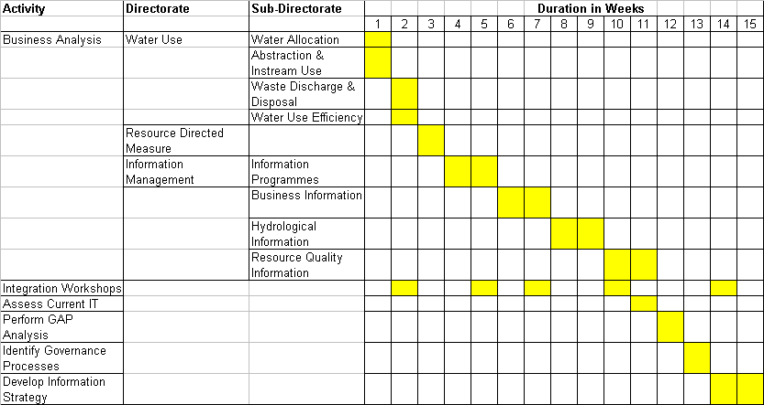

The purpose of the integration workshops is to integrate business processes and reduce duplications.

Cost for Step 1

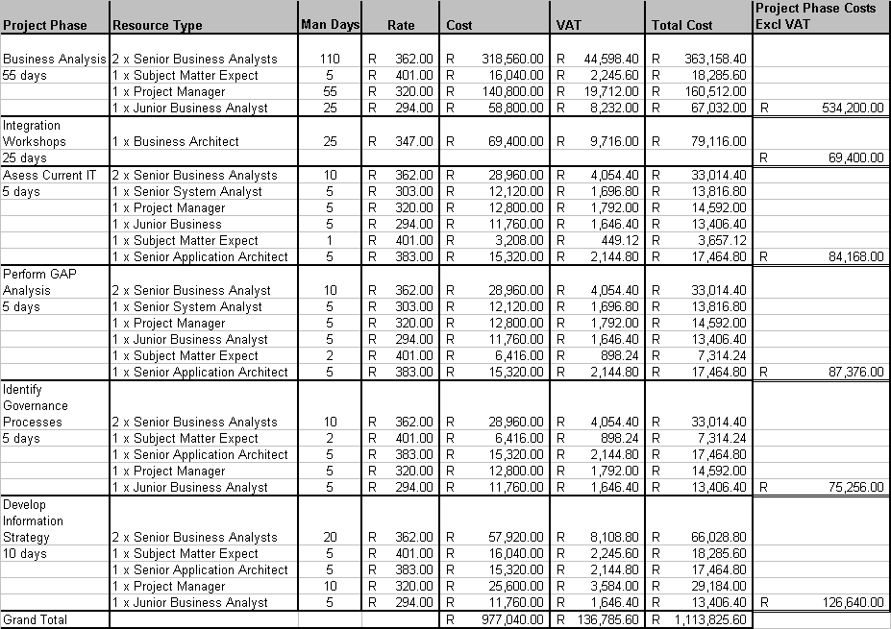

Sundry &Travel costs are not included
As part of the duration for the integration workshops, it can be assumed at this stage that the following will be required:

- Preparation for the JAD
- Documentation including the modelling of processes
- Review of JADs and their documentation (more than one JAD session will be required)

Step 2

Do a detailed business analysis at the cluster (CMA’s) level and then update or align the IMS as per the results from step1.

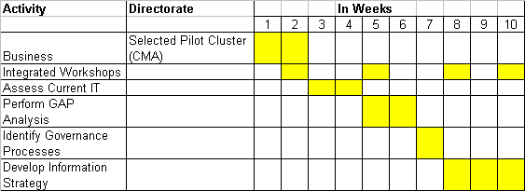

Cost for step 2:

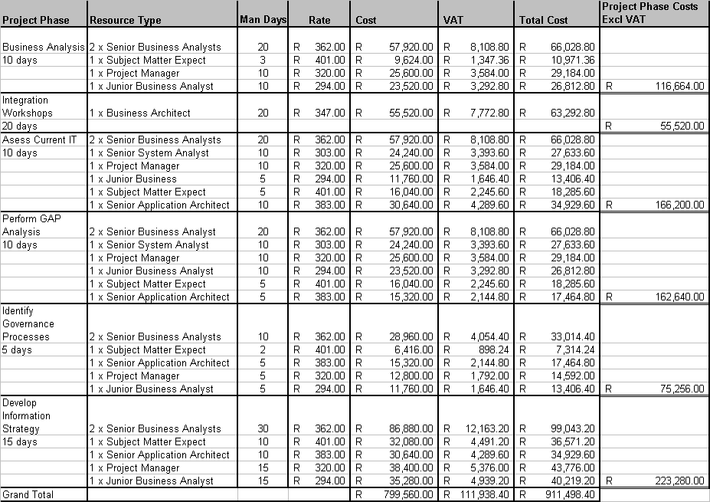

Step 3

The remainder of the business units not covered in step 1 are completed.

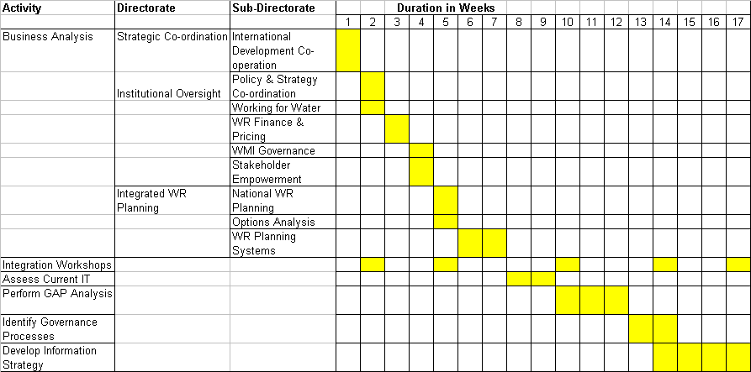

Cost for Step3:

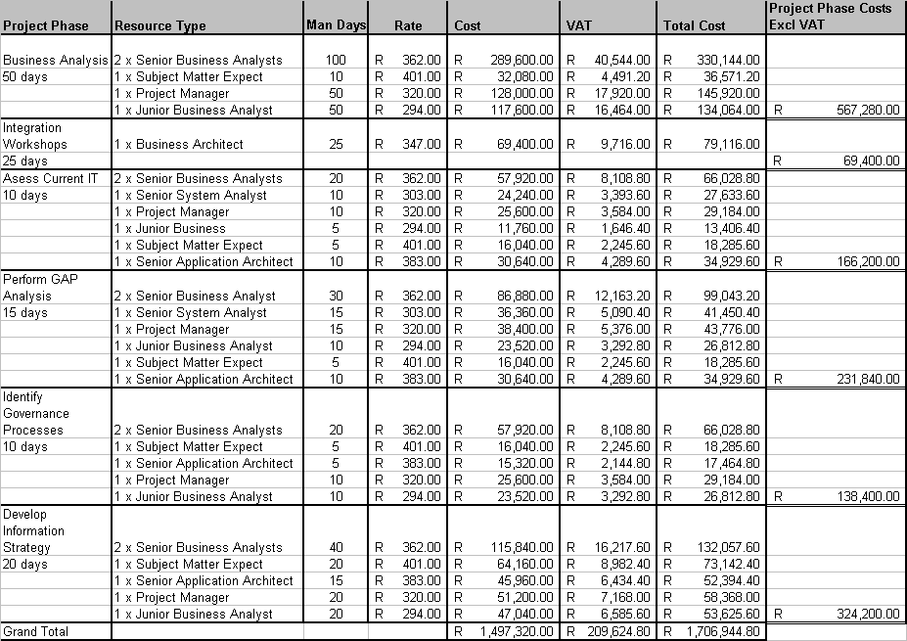

Step 4

This involves a parallel approach whereby Business Analysis and Current IT Assessment occurs in concurrently. It must be noted that this will reduce the time-frame of step 1 from 15 weeks to 13 weeks.

The GAP Analysis will require an extra 5 days to accommodate the fact that the two teams were dealing with complete different tasks i.e. Business Analysis and IT Assessment respectively.

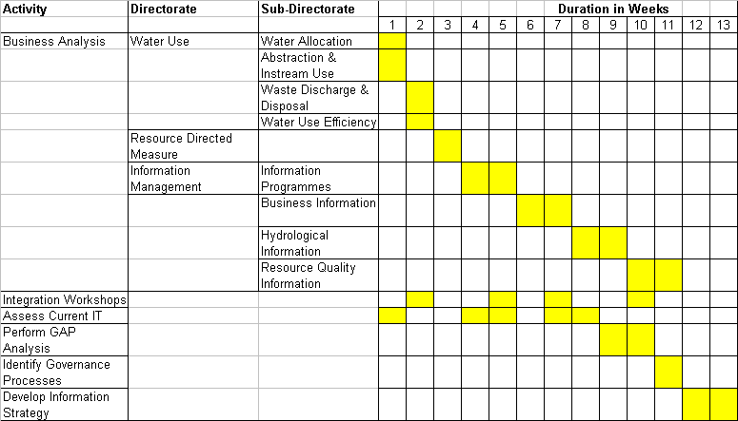

Cost for Step4:

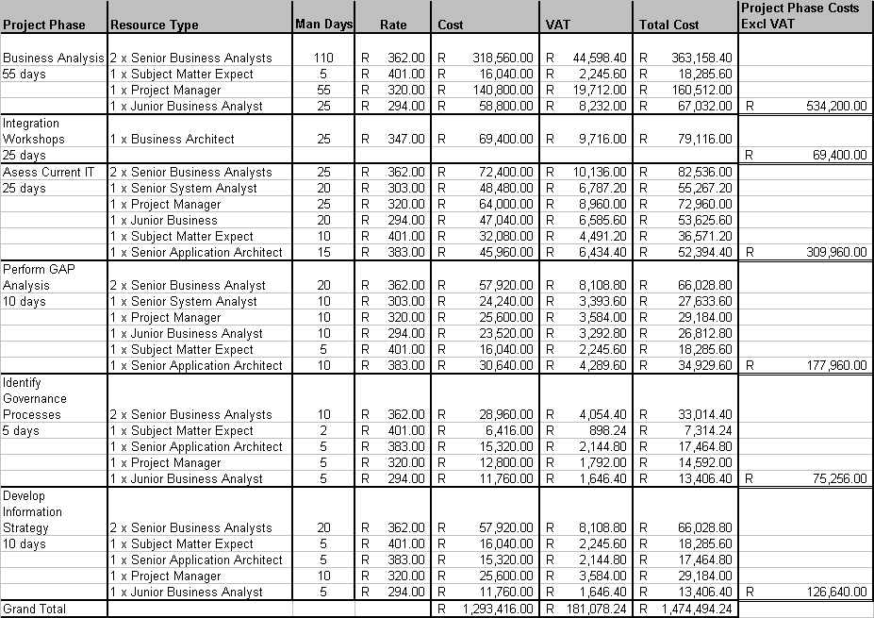

The parallel approach will require extra resources as follows:
- 2 x Senior Business Analysts
- 1 x Senior System Analyst
- 1 x Junior Business Analysts

ANNEXURE A: OUR UNDERSTANDING OF WRM BUSINESS

A.1 Context Diagram

Figure 4: Context Diagram.

The external members of the project team appreciates the opportunity to present their independent perception of the WRM functions and the changing environment it operates in, as it developed during the series of interviews.
The picture above illustrates our understanding of the business context in which Water Resource Management (WRM) operates. This is done within the context of the following:

- The business objectives of each business unit within WRM
- Business Functions within each business unit
- Core services rendered by WRM
- The legislative framework governing WRM. This will include among others the KFA’s
- Customers received by the WRM
- The distribution channels by which the services are provided; and
- Other external bodies interacting with the WRM

A.2 LEVEL 0 - Information Flow Diagram

The diagram below illustrates our understanding of the Level 0 Process Flow Diagram of WRM business and with it is the data source for each stage of the process flow.

F 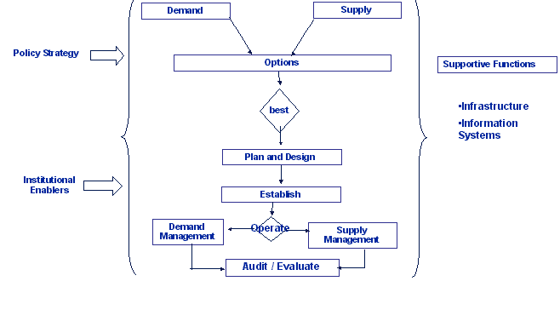

Figure 5: Basic process flow diagram.

A.3 The ‘Old’ vs ‘New’ Paradigm of WRM

The first picture illustrates the conventional way in which the WRM was conducted. It is clear that this method is more product-centric and the technical system does not involve the integration of resources (and systems) and technology is not fully utilised.

Figure 6: The Old Paradigm

This clearly illustrates the conventional way in which DWAF has been operating. Given the recent restructuring, the Department is preparing itself to operate in a different fashion as illustrated in figure2 below.

There are a number of exceptionally strong driving forces in the business environment of water resources management in South Africa and Southern Africa, which have made a special focus on water resource information management an imperative. The most influential force has been the National Water Act, 1998 with its mandate to establish national monitoring, assessment and information systems as fast as is reasonably practicable. In order to give effect to this mandate, an Information Management component was established in the Policy & Regulation Branch of the restructured Department.

The rationale for Information Management is to consolidate the technical and scientific capacity required to collect and manage water resources and other information, and to provide it to DWAF and other clients in an appropriate form to support decision-making processes.

Figure 7: The New Paradigm

Strategically, through the establishment of CMAs and other WMIs, the new entity will have a much greater external focus, both in terms of data and information users and providers. The main intention is to achieve and integrated information service in support of Integrated Water Resources Management.

Structurally this has been addressed through the establishment of more integrated sub-units e.g. the Hydrological Services group containing both the hydrological and geohydrological capacity of the Department. Furthermore, the Information Programmes sub-unit is to serve as client window and co-ordinator/integrator for the whole Information Management unit. To work towards a unified implementation, Information Management will act as lead agent for the whole National Monitoring and Information System described in the Act, covering all aspects of the natural impacted and managed water resources system. It will also work towards increasing system custodianship as these systems start serving multiple users inside and outside the Department.

This new paradigm illustrates what is termed Integrated Water Management. This is an effective approach to deal with the many interlinked issues surrounding the use of water in both the natural and built-up environments. Integrated modelling of water on a catchment-basis is set to play an increasing role within integrated water management as a key tool for planning and potentially for operations uses.

This approach requires planners to take a long-term view of the multiple pressures on water use within a catchment to consider the long-term sustainability of any measures adopted for say developing water resources for public supply by considering also the needs for environmental/ecosystem protection and flood control.

The benefits of taking an integrated approach to Water Management covering the whole water cycle throughout the entire river basins are now recognised and is working its way into practice. The increasing pressure on water resources has further intensified this need.

It is a general requirement that Water Management is based on an integrated assessment of groundwater, surface water and water quality.
The following steps are required in order to protect and rehabilitate all types of water bodies and bring together the planning and management of water in a holistic way:
- Identification and characterisation of river basins (e.g. identify protected areas etc).
- Comparing current status of river basins districts with environmental objectives.
- Defining measures to prevent degradation and/or to enhance the quality of river basins districts.
- Developing plans to achieve the desired status in individual river basins districts, and
- Developing and/or modifying existing programmes to monitor the status of river basins districts.

As populations and economies grow, water demand increases while the availability of the resource remains constant. Accordingly:
- developing multiple sources and
- managing multiple uses (municipal, industrial, irrigation)
- more efficient water resource supply systems
- maintaining or improving ambient water quality
- reduction of water system losses, privatization, decentralization, effluent discharge regulation, water quality monitoring and enforcement, soil and water conservation programs, non-point source pollution control, and water and soil conservation measures are highly required.

Proper management, protection and exploitation of the water resources is a challenge caused by population growth and increasing pressure on the water and land resources.

ANNEXURE B: DETAILED (INTERVIEW) REPORTS

The following sections B.1 to B.18 covers everything documented during the interview sessions with key role players within the business unit concerned this include Deputy Director General P&R, Chief Directors, Cluster Managers, Regional Managers etc.

This section provides a comprehensive report on each interview held.

B.1 WATER USE

B.1.1 Water Allocation

Background | This unit develops and oversees the implementation of frameworks (policies, strategies, guidelines, procedures) for compulsory licensing and allocation of water between users as part of the Catchment Management Strategy. This includes policy & procedures, allocation equity, compulsory licensing pilot, and authorisation administration.
Information Needs | - Resource Directed Measures  - Administrative Justice Act  - Internal Strategic Perspective (ISP)  - National Water Act  - Constitution  - National Water Resource Strategies (NWRS)  - Integrated Water Resource Strategies (IWRS)  - Business information coordinated with Abstraction & In-stream Use.  - GIS information, co-ordinated with Business Information.
Sources of Information | People : Ash Seetal  Documents : DFID Inception Report, Vol 2, May  2003  Systems : None
GAPS and Concerns Identified | - There are currently no systems in place to directly support this area.  - There is a need to integrate water conservation and demand management into compulsory licensing and water allocation.  - There is a need for both DWAF and CMA’s to be aware of the conditions under which compensation would be paid and the extent of the compensation that may be required.  - There is a need for the development, implementation & testing of the Water Use Allocation methodologies.  - There is a significant need to have access to information from local governments.  - There is a need to get direct access to property details  - There is a need for the co-management of required information and collective reporting.
Existing plans and Initiatives | Co-ordinating sustainable compulsory licensing for a succession of CMAs according to given priorities is an urgent priority to launch. DWAF, in conjunction with the DFID, have initiated a project: Water and Forestry Support Programme (WFSP). The vision of the Water Resources component of the WFSP can be summarised as follows:  - to develop methods for water use allocation and monitoring that:  - take special cognisance of the needs of rural poor;  - ensure participation by the rural poor;  - realise tangible benefits to the rural poor;  - work with other agencies to build capacity amongst the rural poor to use water productively;  - to pilot these methods in at least one catchment;  - to ensure that these methods can, and will be used.  The verification projects are an important part of the follow-up work required.  This project aims at developing processes that will ensure greater equity in the use of South Africa’s water resources.  Initiatives to ensure that this project will proceed include among others:  - Strategic Environmental Assessment (SEA) project identified by DWAF as a tool for Water Resource Management.  - A guide to Stakeholder Participation in the Integrated Water Resource Management (IWRM), which was developed by DWAF and the Danish government (DANCED).
Quick Wins | A very urgent co-ordination with IM to determine & address urgent needs regarding monitoring, data & information collection and its management.

B.1.2 Abstraction and In-stream Use
Background | The unit is responsible for developing and overseeing policies, objectives, strategies and guidelines around the control and authorisation of water uses relating to abstraction, storage, stream flow reduction and diversion, in-stream activities, alteration related water use, stream and recreation, as well as national dam safety and sustainable utilisation and environmental management plans.  The main current driving force of this unit is Licensing, both ad hoc and compulsory.  It is foreseen in the long term that licensing activities will be handed over to CMAs and this unit will retain the regulatory functions, though part of it will be delegated to cluster managers.  The Dam Safety Office will similarly continue to ensure that dam safety responsibilities are met, and managed in line with disaster management requirements.  The auditing of institutions on compliance to policies, guidelines and license- conditions will in future be the major focus area.
Information Needs | - The unit has a tremendous need for information on water use & users, the availability of water, approved reserves, history of water rights and utilisation, key performance indicators for compliance monitoring, key performance indicators for policy audits i.e. to check the effectiveness of the policies that have been put in place.  - Information needed to draft policies and procedures, like the equity aspects of water use.  - Data and information from regional offices on water and land use.  - Systems from which information is obtained; WARMS, HYDSTRA (HIS), GIS, PlanDB and smaller systems and utilities.  - SAE Decision Support System (currently under development)  - Extraction of concise and timely information on Deeds and property details.
Sources of Information | People : Piet Pretorius, Flip Nöthling (especially  regarding the consolidation of licensing  information), Mike Warren, Obed Baloyi,  Loraine Fick & Anet Muir  Documents : Strategic documents (?), P & R  Restructuring Document, SAE  Documentation, Carin Bosman Document, Consolidated Integrated Management Plan, National Environmental Management Act, National Water Act 1998,Conservation of Agricultural Resources Act (CARA), Biodiversity Bill/Act (new), Promotion of Administrative Justice Act (PAJA), Forest Act, Environment Conservation Act (1989). The following SFR policy & guideline documents are available on the Internet:  - Water Use Licensing: Policy & procedure for licensing stream flow reduction activities  - SFRA Combined Licensing and Authorisation Guidelines  - Policy & Guidelines for the establishment of Advisory Committees  - Terms of Reference and Guidelines for SFRA Licensing Assessment Advisory Committees (LAACs)  Systems : SAE
Existing plans and Initiatives | - Verification Projects, to establish lawful water use and have historical data of water users. The only information available on WARMS is from 2001.  - SFRA Water Use Licensing System.
GAPS and Concerns Identified | - There is a lack of regional capacity and resources to provide data.  - There are problems in obtaining special data and information from regions.  - A lack of a coordinated approach to the information needs for licensing and compliance monitoring.  - Need for Integrated Reporting  - Need for Document and Version Control  - Improved access to information  - There is a need for a single point of contact for integrated monitoring programmes.  - There is a need for an improved & automated license tracking system.  - A need to have more insight into the DFID projects  - Lots of old data and information systems lying around, like the old water rights database, which are not very accessible.  - A significant need for socio-economic data and information, specifically for the equity aspects of water use.  - A need for performance indicators referring to the state of water resources.  - Information to support the trading of water allocations between units/sectors.  - Several questions regarding the administration of license applications need answers.  - The Environmental Management Framework and Integrated Environmental Framework will need a database to support its work.  - A critical need for a one stop shop or single point where all information can be accessed.  - The annual CIEMP report to EA needs a database to draw its information from.  - There is a huge need for automated reporting straight from databases on all aspects.  - Internet sites are not updated regularly.  - Licensing information and conditions are at several places in DWAF and difficult to access.  - Links to the River Health Programme and the information systems for Working for Water are required.  - A need to upgrade PlanDB for Dams, consolidate DWAF Reservoir data and have it linked to GIS
Quick Wins | - Effective, well co-ordinated data and information management.  - Proper Strategic Plans and Strategy Implementation Plans.

B.1.3 Waster Charge and Disposal
Background | The unit is responsible for policies, strategies and guidelines to control and authorise waste discharge, waste disposal and controlled activities like waste water storage and irrigation. Services provided include guidelines on water quality guidelines for users and to advise on the authorisation of all these activities until it is transferred to CMAs. These responsibilities are given effect by providing water quality management instruments, facilitating water use authorisation, guiding various technical operations (e.g. water quality management in the Upper Vaal.), the verification of the procedures and operations and the required communication and information management activities.
Information Needs | The collective information needs for both the strategic water quality monitoring programmes and the management of the quality of water by controlling waste- water activities through monitoring specific activities, has been addressed by the collective specifications for the Water Management System (WMS). Development of the system consisted of several modules and the absorption of several water quality databases. Implementation has experienced difficulties, but rollout to all regions is presently underway.
Sources of Information | People : Sakie van der Westhuizen, Geert  Grobler  Documents : Register of Business Processes with  detailed activity break-down.  Systems : WMS
Existing plans and Initiatives | - CMAs will in future be serviced as autonomous units, populating and using WMS data and facilities through thin-client technology (e.g. Winterm)
GAPS and Concerns Identified | - There is concern about the uncertainties regarding the management of WMS development.  - There is a significant need to address the information issues around compliance management as quickly as possible.
Quick Wins | - A high level support for WMS

B.2 STRATEGIC CO-ORDINATION
Background | This is a new business unit that is responsible for co-ordination of different policies and strategies within Water Resource Management in line with the priorities and budget allocations in the Department’s strategic plan and expenditure framework. This unit does not only see itself as a co-ordination unit but also as a reporting channel in terms of strategic information that is required for both policy making and decision making in the department.  Resource allocation, especially budget allocation is an essential function in this unit.
Information Needs | - This unit does not only require a proper information management but also an enabling environment for storing information due to the fact that information is always increasing and not necessarily changing.  - The information that is required should cover the following aspects: (KPA, Strategic Plan, Output, Key Objectives, Role Players, and Availability). Information required should be in line with the Key Performance Areas and then aligned strategic plans and business plans. The information should also identify and monitor key objectives, role players and the availability of those role players.
Sources of Information | People : B Rowlston, C Swiegers, J Beumer  Documents : See the National Water Resources  Management Strategic Framework  document on internet.  Systems : National Disaster Management System
Existing plans and Initiatives | - The Disaster Management section of this unit has been involved with National Disaster Management developing a disaster management framework that will be utilised from National, Provincial and Local Governmental levels. This framework incorporates other organisations like NDA, DEAT and Weather Services. DWAF, in conjunction with these organisations intend developing a common Disaster Information Management Strategy that will be controlled by NDMC.  - Strategic co-ordination has already purchased system for their Dam Safety Information, called EDMC1.
GAPS and Concerns Identified | - There is no clarity in terms of whether a KFA should be seen as a single function whereby it should be accounted to a single manager responsible for coordinating that specific KFA, funding and managing expenditure per KFA is presently not possible.  - Indicators linked to various performance monitoring systems should roll up to present management information at a strategic level.  - Lack of coordination has lead in previous “silos” being reorganized into new silos.  - Co-ordination of P& R with OPS is not being fast tracked. This can cause duplications, overlapping and thus retard progress in the department.  - Cross-cutting plans in the department are not receiving adequate attention.  - We need to store spatial data and attribute data in the same GEO database and identify common standards for data exchange.  - The Disaster Management Database is not accessible.  - There is a need to link DWAF systems to those of the NDMC  - There is a further need to link the DWAF system up with others outside DWAF.  - The Stakeholder database currently at this unit must be integrated with others in DWAF and supported by an adequate data administration group.
Quick Wins | - Formulation of a user group for information sharing  - Embarking on a detailed business analysis to identify the appropriate information required by this unit

B.3 RESOURCE DIRECTED MEASURES
Background | The unit provides a framework to ensure sustainable utilisation of water resources to meet ecological, social and economic objectives to audit the state of South Africa’s water resources against these objectives.
Information Needs | - The unit is heavily dependent on information from several other units and regions  - There is a big need for a one-stop service where final, accepted, official versions of refined information products like catchment yields are stored.
Sources of Information | People : H Pienaar  Documents : Old Documentation on an Information  Management User Group (Outstanding),  SAPTSAM System Description (Outstanding), Strategic Advocacy  Proposal (Outstanding); Conceptional  Design on How RDP Should Operate in  DWAF (Outstanding)  Systems : SPATSAM, an operational model and  DSS
Existing plans and Initiatives | - High-level process analysis is now underway in cooperation with HRM.  - Would like to establish single point of contact per region/CMA responsible for RDM information exchange; this should be extended to other government departments as well.  - The monitoring needs for Resource Quality Audits must still be addressed.
GAPS and Concerns Identified | - The unit has an urgent need for detailed process analysis  - There is also an urgent need for assistance in the analysis and provision of information management services.  - There is a need to link up with the planning systems  - There is a need to establish a licensing user workgroup  - Monitoring for resource protection initiatives is required, who should do it?  - The SPATSAM model/DSS should become the DWAF standard.  - There is a significant lack of knowledge in DWAF about what information is available in DWAF and where it is.  - There is now a significant need for leadership in the information management of DWAF and there are significant expectations in this regard regarding future support and services provided by the newly formed Information Programmes.  - Several studies have been undertaken but their results are not available, it is known that some of them include reserve determinations.  - Information management tools are required to support the resource classification systems.
Quick Wins | - Several very good information systems exists, they must move closer and be more accessible.  - Use KFA 9 as a management tool and not only a reporting structure  - There must be detailed (sources etc) inventories about available information and services available in DWAF.  - There is an urgent need for a management information system to address reporting and future plans.

B.4 INSTITUTIONAL OVERSIGHT
Background | Institutional Oversight is a chief directorate that create an enabling environment for the establishment, development, manage and audits local and regional water resource management institutions. It constitutes of three units, WR Finance and Pricing, WMI Governance and Stakeholder Empowerment.  The WR Finance and Pricing is responsible for developing a pricing strategy and also manages the financial viability of Water Management Institutes (WMI).  The WMI Governance develops governance frameworks and manages the establishment of Water Management Institutes and Water Boards.  Finally the Stakeholder Empowerment sub directorate provides guidance and oversees processes of stakeholder participation representation, redress and disputes between stakeholders.
Information Needs | - Require information within DWAF, about water quality and quantity in specific areas so that they can make informed decisions pertaining to institutions in that area.  - Require information from other external organisations about demographic, social and socio-economic factors so that they can make informed decisions pertaining to institutions in that area.  - Require a tracking system to monitor different projects progress in institutional development.
Sources of Information | People : Jean Msiza, Francios vd Merwe, Paul  vd Merwe Derek Weston and Fuad Moerat  Documents : Social Assessment Development  Systems : None
Existing plans and Initiatives | - They have already taken an initiative of investigating their actual information needs  - Established a framework for water pricing with other organisations
GAPS and Concerns Identified | - Information Management should provide quality information that can be shared and also used to support respective units.  - There is a need to establish a legal framework that will support their function in establishing institutions  - Co-ordination of information as a priority
Quick Wins | - Liase with WR Planning and establish if they cannot acquire relevant information from them.

B.5 INTEGRATED WR PLANNING
Background | The unit develops national strategies and procedures for the reconciliation of water availability and resource quality, as well as the requirements to meet national social and economic development objectives. This includes the strategic requirements, resource quality objectives and international obligations. These responsibilities are executed through catchment management strategies: options are developed to address future requirements taking possible changes in the status resources into account.
Information Needs | A large variety of data and information is required and many studies are undertaken to assess water-resources and -requirements.
Sources of Information | People : J v Rooyen  Documents : See P & R Restructuring Version 5.4,  Breede River CMA-ISP (G v Zyl) &  Mhlatuse Study on Data management (A Görgens), 10 ISPa to be made available by Dec 2003, J v Rooyen’s Water Resources Management diagramme.  Systems : Data, information and  models required are provided by WR Planning Systems.
Existing plans and Initiatives | - Currently the development of Interim Strategic perspectives (ISPs) is regarded as a priority, these are to serve as reference documents for regions during licensing.  - The next priority to be addressed shortly is compulsory licensing, starting with Mlutuse and shortly also Komati, Olifants (East) and Berg catchments.  - Information systems to support interest based bargaining is required; currently a ToR is being drawn up for such a system.
GAPS and Concerns Identified | - Reports on studies undertaken in DWAF are frustratingly dispersed throughout DWAF and it is difficult to have information on what has been done and should be available.  - Clear guidelines are required for regions on how information should be managed in future CMAs.  - There must in future be a single information management system to draw information in from the CMAs into a National Decision Support (DSS) system.  - Similarly, CMAs must have access to appropriate information stored on their catchment at DWAF.  - It is very important that all involved in interest based bargaining will refer to the same numbers; somehow a decision will have to be taken on recommended records and models.
Quick Wins | - An advisory committee on recommended DSS is urgently required.

B.6 PLANNING SYSTEMS
Background | This unit is responsible for the evaluation of strategic water resources management challenges and to address them through the development of resource orientated policies, strategies, programmes and assessment tools, and to provide resource management decision support to other components.
Information Needs | A wide spectrum of data and information from monitoring programmes in DWAF, institutions outside DWAF (economic & social data), refined information products like catchment studies and results from analyses done with models.
Sources of Information | People : C Moseki, M Watson.  Documents : All documentation available from Bennie  Haasbroek.  Systems : WSAM, GIS Viewer, Economic  Indicator System, Demographic User, Rainfall Sysem, Effective user support systems, data pre-management service to modelers.
Existing plans and Initiatives | A wide spectrum of systems are being developed and put into sound operational environments where they are generally available for wide use to empower people to make their own decisions.
GAPS and Concerns Identified | - Several similar projects are currently being pushed, it is urgently required that development on multiple information systems be stopped, here must be only one system providing information to the water resources management functions.  - There are also several WRC projects going ahead, apparently for different information systems.  - There are also several different initiatives outside DWAF and the WRC going ahead on models and data support systems for models.  - It is, however, very important to understand the apparent (not true) duplication in some cases, it is therefore very important to understand and address the underlying needs that led to these developments.  - There is a concern that IS takes their decisions in isolation and not in participation with business.  - There is an urgent need for a single database with layers of data, building up to more sophisticated information products, allowing users to plug their models into, to drill down into the basic data components.  - Results from analysis and studies must be made available to all users.  - The lack of general use of WSAM is a missed opportunity for DWAF. It should be put into general operation as soon as possible.
Quick Wins | - It is now very important to take the lead in unifying business approach to information management, to bring interested parties together, get our house in order to manage the process to meet the challenges by combining our present resources. This must be done before the rest (long term aim) of this study is addressed.  - It is quite urgent to get the WRC’s WR2000 & 2005 projects to share databases & records with DWAF.  - The WR2005 project should also include a viable continued support service to keep it current.  - Find a way to bring all stakeholders in information management and modelling together to make some serious decisions about the future of the management of information for water resources management

B.7 INFORMATION MANAGEMENT

B.7.1 The Chief Directorate: Information Management.
The role of the unit is to develop and maintain the required systems and programmes for data and information acquisition and monitoring, assessment and management. It must also coordinate, support and audit their implementation by DWAF and other Water Management Institutions.

For the WRM functions to make optimal decisions Information Management needs very reliable information and it must be clear which are the policy imperatives to meet. This now requires a higher level of integrated systems that the old structures could not meet. The new structures must also address plans to drive up skills levels and improve equity. The availability of adequate human resources in the management of information is a cause of great concern.

We are now in an open society and under close scrutiny, this means people as well as decision makers must have good access to reliable information to promote transparency, taking into account that water resource management will in future be delegated to the smallest unit, namely CMAs. Although CMAs will have ownership of collected data, they are ultimately responsible to the minister on how it is managed which should now already be part of the ISPs. Reporting requirements from CMAs will also not be limited to Water Resources only, but must also include information on other local conditions.

It is clear that DWAF is now getting to grips with its new tasks and the challenge is where to begin, it must be an integrated approach: Information Management must now respond to the needs of business by taking the leading role towards integrated information management to support integrated decision making. This will require close and continuous contact and coordination with business working from joint strategic plans. This must be a collective approach that should bring both the high level conceptual and detailed knowledge together.

Information Management must play a leading role in providing reliable information to the full spectrum of users, from the minister to the smallest stakeholder. In this approach the effective use of low-tech approaches must be considered.

B.7.2 Information Programmes
Background | Information has become a significant resource within the Department. This fact is highlighted by the new management structure, creating a business unit solely responsible for the management of information at DWAF. DWAF has a legal obligation to manage and distribute information on Water resources. Exceptionally strong driving forces in water resources management in Southern Africa have made a special focus on water resource information management an imperative. The most influential force has been the National Water Act, 1998 with its mandate to establish national monitoring, assessment and information systems as fast as is reasonably practicable. In order to give effect to this mandate, an Information Management component was established in the Policy & Regulation Branch of the restructured Department. The rationale for Information Management is to consolidate the technical and scientific capacity required to collect and manage water resources and other information, and to provide it to DWAF and other clients in an appropriate form to support decision-making processes.  Strategically, through the establishment of CMAs and other WMIs, the new entity will have a much greater external focus, both in terms of data and information users and providers. The main intention is to achieve an integrated information service in support of Integrated Water Resources Management. Structurally this has been addressed through the establishment of more integrated sub-units e.g. the Hydrological Services group containing both the hydrological and geo-hydrological capacity of the Department.  Furthermore, the Information Programmes sub-unit is to serve as a client window and coordinator/integrator for the whole Information Management unit. To work towards a unified implementation, Information Management will act as lead agent for the whole National Monitoring and Information System described in the Act, covering all aspects of the natural impacted and managed water resources system. It will also work towards increasing system custodianship as these systems start serving multiple users inside and outside the Department.  The NORAD programme is working closely with Water Services, introducing supportive mechanisms for sustainable groundwater supply projects for local communities.  The DANCED programme is working on a “toolbox” for sustainable resources management in future CMAs and the project is based on 3 legs: Institutional Arrangements, Water Conservation and Demand Management and Sustainable Groundwater Management.
Information Needs | - Since data is collected by different agencies using different methods, IM needs to develop methods to collate and structure the information in a way that the integrity of the data is maintained. In turn IM need to be able to provide information cutting across all business units for effective and efficient decision-making.  - IM also needs to benchmark their standard and processes to ensure adherence to best practices.  - DSS and Central knowledge bases are imperative to provide collaborated information for reporting purposes.  - Some of the objectives in Information Management is to serve clients in terms of providing secure reliable data and developing a knowledge base. Innovative idea generation and the development of cost effective and wealth creating alternatives are key factors in providing this reliable, efficient and secure information.
Sources of Information | People : Ebhard Braune , Herman Keures, Chris  Moseki, Boniface Aleobua and Fortunate Makhubu  Documents : Strategy document for Information  Programmes, MAIS,TINWA, DANCED  & NORAD  Systems : None yet
Existing plans and Initiatives | - Client-need analysis and inventories of data, information and services;  - Developing a common website for sharing information;  - Develop a Modelling-Advisory group;  - Co-ordinate common monitoring programmes like rainfall and water-use;  - Liaison/ link between WRM, WS and Forestry;  - Introducing systems to audit and control monitoring programmes;  - Implementation of the DANCED Project. This project is aimed at developing a toolbox for sustainability of WRM for future CMA’s. It is piloted in Olifants, KZN and Crocodile in North West Province, and  - Playing a leading role in improving the quality of analysis being done throughout DWAF, especially for integrated analysis of water resources and to have staff ready and trained for CMAs.
GAPS and Concerns Identified | - Clarification of future data and information ownership;  - Multiple and uncoordinated communication channels to regions;  - Prioritisation on data /information that should be collected at the regions;  - A lack of Subject Experts / Portfolio Managers;  - Lack of business, systems and organisational integration;  - Lack of management knowledge of, and support to the NORAD programmes;  - Who should in future manage the information systems developed by NORAD?
Quick Wins | - Carry IM mission into DWAF and develop a common understanding, and  - Introduce IM Governance to implement the difficult decisions required to make integrated information management work.

B.7.3 Business Information
Background | The Business Information Directorate provides information services ranging from the acquisition, analysis, storage and distribution, the management and application of spatially referenced data, to the provision of information products. It embraces the traditional areas of surveying and mapping, such as geodesy, cadastral surveying, photogrammetry and hydrographic surveying, as well as the comparatively new fields of remote sensing and spatial information systems.
Information Needs | Businesses Information uses various kinds of information from different sources; these data include information on rivers, roads, contours etc. This information is also required by various external sources.
Sources of Information | People : Alison Gouws , J de Klerk  Documents : Strategy document, see Intranet  Systems : GIS
Existing plan and Initiatives | Business Information is committed to capture all of Business Information Data with an easy to use, available and low-cost capture tool(s). The second part of the vision is that all this data must be made available at no extra cost to users over the Intranet will full geographic viewing and querying capabilities. Any user with a browser must be able to query and view the data in a geographic way. Because non-spatial attribute data is dominantly available in database systems, this query system needs to integrate seamlessly with different databases with different formats in real time.
GAPS and Concerns Identified | - There are many useful isolated databases out there. To incorporate such systems into a corporate database system and preserve referential integrity at the same time is difficult.  - Duplication of efforts and initiatives between Water Services and WRM in respect of GIS related projects and services has been identified.
Quick Wins | - Incompatible reference and classification schemes need to be resolved, different data formats needs to be synchronised etc.  - There is a need for the integration of isolated database systems without any costly and time-consuming rewrites. This means a solution should be found to incorporate different databases automatically without any change to current structures, definitions or classifications.

B.7.4 Hydrological Information
Background | This business unit is responsible for the collection, maintenance and support of hydrological and geohydrological-monitoring systems for current and future information needs of water resources management, ensuring that the regional offices and other water management institutions coherently implement these functions. The raw data is collected at regions using a range of collection methods. It is then stored at regional databases for editing and quality control before it is moved to the national database where it is audited.  Groundwater monitoring networks are managed at three levels: national or background, impact monitoring and local or compliance monitoring.  Much progress has been made in switching to electronic monitoring equipment that uses supplier software to extract data.  The surface-water monitoring programme is currently supported by the HYDSTRA commercial database, which also offers groundwater and water quality modules.  The geohydrological monitoring programme is currently supported by the Open-NGDB while the development of the replacement National Groundwater Archive (NGA) is underway. The REGIS Africa system will be used to visualise, analyse and present data from Open-NGDB. To support the seamless data transfer from numerous systems to REGIS Africa, the corporate team has been working since the end of previous financial year on a middle-ware solution. This includes a link to the WMS to access groundwater quality data and to HYDSYS to obtain surface water data and rainfall. These systems have already been aligned with corporate models such as features, classification etc. Geohydrological data are supplied as records, maps, brochures and information sets. Geohydrological information systems will provide its data services to all users through the internet where-as HYDSTRA will do so through a thin client technology like Winterm.  The flood control office manages a series of utilities into which the telemetry and satellite networks are feeding data, as well as a direct link to the South African Weather Services for forecasts and satellite images. These data, forecasts and general flow data are all available from DWAF web-site to users (40 000 hits since 1998). Cell phone and SMS technologies are now gaining in popularity for telemetry networks.  The SADC-HYCOS Pilot regional Center where hydrological data from up to 50 gauging stations received via satellite in Southern Africa are being stored on behalf of the SADC/European Commission project, already has 30 to 50 regular international Internet customers.  A significant selection of utilities and models are also used to analyse data and to produce refined information products ranging from flood frequency analyses to catchment yields and the simulation of various configurations of water supply systems.
Information Needs | - Hydro and geohydrological data as collected through the monitoring networks  - Rainfall data from the Weather Bureau, hydrology stations and geohydrological stations  - Need historical information to be incorporated in the new information system.  - Need information not to be a one way stream into Hydstra but it should be able to be disseminated to the regions effectively
Sources of Information | People : S v Biljon, J v Heerden, F Wulff, E v Wyk,  D v/d Spuy, F Cornelius, E Nel, J Girman, E Bertram, G Booysen, Brink du Plessis, Andre Delport H Mullin  Documents : Report on IT Services Delivered to  Geohydrology; National Groundwater  Related Data Acquisition and Capturing Strategy. Comprehensive Business Plan for Geohydrological Systems, Data Diagram of the Hydrological Data Chain from a Regional Perspecive  Systems : Hydstra, Open-NGDB, NGA, REGIS-  Africa, Satellite, Vaal/Bloemhof Telemetry,  Flood Management programmes, Catchment analysis & modelling programmes, Flood & rainfall frequency analysis programmes, SADC-HYCOS database, Gauging Station Calibration  Programmes.
Existing plans and Initiatives | - Regions must be capacitated to take full ownership of data and monitoring programmes under head office guidance over the next 5 to 10 years.  - During the next 10 to 20 years regions must build the same capacity in CMAs and take over part of the assessment and auditing role on monitoring.  - Increased use of near real time systems to improve data quality.  - Search and evaluate cheaper and more effective technologies.  - Upgrading the Weekly reports to be a decision support service.  - Form a user support group for Hydrological and Geohydrological services.  - Established a control mechanism to request for data / information.  - Rainfall networks are now established in mountainous areas.  - A National data management strategy is under development.
GAPS and Concerns Identified | - There is a need for methodologies to optimise integrated monitoring networks.  - Slow development of corporate systems is causing serious delays to NGIS.  - Trained human resources to manage more sophisticated information systems remain a critical success factor.  - There is a serious need to collect and consolidate water use information  - The monitoring needs for RDM is not yet fully understood  - Despite progress, clients are still bitterly complaining about difficulties in obtaining data and the formats, in which they are supplied, refer to Escom’s complaints to Dr Green at the WRC.
Quick Wins | - To catch up with backlogs in capturing geo-hydrological data, new strategies like those for surface water data and other WMIs must be explored as a matter of urgency.  - Very urgent attention must be given to expediting corporate information structures to keep pace with the development of the NGIS.  - It is vital to get appropriate information systems ready for CMAs.  - MANCO decision on whether the CMA’s will be forced to use current DWAF information systems.

B.7.5 Resource Quality Information

Background | The unit is responsible for the establishment and maintenance of water quality and river health monitoring systems for current and future information needs of Water Resources Management. It must ensure that these programmes are coherently implemented by DWAF, Regions and other Water Management Institutions through the assessment of the quality and reliability of the monitored data. The unit is also managing an accredited, automated laboratory where 14 000 samples per year are analysed for 10 to 12 variables. These results and those analysed by other laboratories are managed in the national database of the Water Management System (WMS). The WMS contributed greatly in the consolidation of water quality data.
Information Needs | - There are urgent needs to link quickly to the NGA and HYDSTRA systems  - Users must be very closely involved in future developments  - Regional offices collect samples and local, accredited laboratories do some analysis.  - WMS modules are implemented in the following phases: Monitoring Management (high priority), Polmon Transfer to WMS, Compliance-Standards & Objectives, Comprehensive Monitoring, Multimedia, Backlog (historical) data, GIS & Spatial data.
Sources of Information | People : T Duma, C le Grange, U Looser, B  Madikizela, Kobus Myburg & Bets  Documents : See Comprehensive Business Analysis &  WMS documentation  Systems : WMS, LIMS, GIS Scientific Applications,  Web-Site
Existing plans and Initiatives | - Reaching out to the public through a series of newsletters and bulletins  - Looking at a future role of close scientific support to CMAs doing their own water quality monitoring and management.  - Looking for new technologies and instrumentation in monitoring;  - The laboratory Information Management System (LIMS) needs replacement in future.
GAPS and Concerns Identified | - A lack of appropriate and dedicated resources in regions to execute monitoring programmes;  - Looking at Information Programmes for guidance and co-ordination of national monitoring programmes.  - Not all regions are using WMS for their water quality data management.  - There is a concern about the loss of corporate knowledge before it can be captured in information systems.  - There is still too much duplication, especially regarding Web-access and reference systems.  - Reporting from the different systems is difficult and costly.  - DWAF is not providing a good hydrological information service to the general public.
Quick Wins

B.8 REGIONAL CO-ORDINATION
Background | Note: This investigation only focussed on the Water Resources Management part of this unit.  The 9 regional offices are each the size of an average government department, though they are diverse in structure, they are interrelated. The branch manager now has 9 chief directors reporting to him (it is being restructured into two units) with a total of 9 000 people reporting. The total capital worth of the infrastructure managed is estimated at R 25 000 000 000. Regional Coordination and support is an important link between regional clusters and Policy and Regulation because regional structures manages 80% of the departments’ budget and is in effect the executive branch for P & R.
Information Needs | - A very large volume of detailed management information is required over a large spectrum.  - Information regarding asset management and maintenance are now seriously needed and is a specific requirement of the PFMA.
Sources of Information | People : A Muller, F Nöthling, T Balzer  Documents : Consolidated Business Plans and Budget;  Report : Review of IT Systems in the Operations  Branch.  Systems : GIS, WARMS, WMS, HYDSTRA, WAS,  OSIRIS, POLMON, REGIS, Open-NGDB, SAP, Budget Systems, PMISS, CEMS, AFS, AFRIGIS, Business Plan, Business Plan Tracking, Certified Expenditure, Dam Safety, Logprog, Capital Works M & E, Per-Form Developer, SCADA Telemetry, Vaal River System.
Existing plan and Initiatives | - The first priority is to capacitate regions to address their present business processes to establish sound processes, which will be transferred to CMAs.  - Regions will then gradually themselves have to move into a support and regulatory role regarding CMAs and other institutions.
GAPS and Concerns Identified | - A significant shortage of management information leads to very difficult decision making;  - The present transversal systems (BAS, PERSAL, Logis) are inadequate in not providing all the reports required.  - There is a serious lack of appropriate personnel to manage information systems.  - Regions have a large number of separate (but similar & overlapping) systems to manage and update, there is a great need for integration: to capture once at source.  - Proper overall data management procedures are needed.  - Proper coordination between regions and both P&R and IS are urgently required to manage the deployment, population and data administration for information systems.  - There is a serious concern that information systems are not properly aligned to regional (and CMA) needs.  - There is a serious lack of resources in regions to operate sophisticated information systems, succession planning is also required.  - A single point of contact/management of regional IT issues is required.
Quick Wins | - Appointment of a high level, very capable portfolio manager to co-ordinate information systems for regions

B.9 WESTERN CAPE REGION

Background
Information Needs
Sources of Information | People : G van Zyl, E Marias  Documents : Southern Cluster Restructuring  Document Example Job Evaluation for an Information Officer, Review of IT Systems in the operational Branch.  Systems : Several, see latter report above.
Existing plan and Initiatives | - The Southern Cluster is currently being restructured: WRM and Data Management will be ring-fenced for the later Utility.  - New Data Management will aim for very fast data throughputs.  - Satellite imagery & real time telemetry will be put to more use.  - Independent validation of water use will receive more attention.  - Improved technology will be introduced.  - Drought forecasting will receive more attention
GAPS and Concerns Identified | - CMAs will need definitive standards and methodologies.  - Significant re-allocation of funding will be required to support future integration of systems.  - Business plans must be linked with Mater System Plans and linked to the ITC.  - Data collected outside DWAF must also form an integral part of future planning.  - Information-clientele must be segmented (schools, general public, license holders, etc) and planned for.
Quick Wins | - Data-warehousing, including a virtual warehouse must be introduced soon.

B.10 CORPORATE / INTEGRATED INFORMATION SYSTEMS
Background | The team attached to the Office the CIO has been doing design and development work on enterprise architecture. Concept architecture has been designed and detailed structures proposed for core/corporate data.
Information Needs | - Future system needs for corporate data.  - User-Centric service delivery: processes/Business Analysis. Currently looking at a product called RUP  - Access Control: security policies and applications, data protection  - Integration: interfacing / integration of applications and data in particular transversal systems  - Presentation: Portal/ ETL/ MIS/DSS/Web
Sources of Information | People : E Trenerry, D Hall  Documents : Data structures and Enterprise Designs  (Outstanding)  Systems : Access Control, Stakeholders, Features, Classification and Meta-data
Existing plan and Initiatives | - To convince business to buy-into corporate initiatives.  - User-Centric service delivery: processes/Business Analysis. Currently looking at a product called RUP  - Access Control: security policies and applications, data protection  - Integration: interfacing / integration of applications and data in particular transversal systems  - Presentation: Portal/ ETL/ MIS/DSS/Web
GAPS and Concerns Identified | - There is a concern about a lack of funding, business ownership and a team to address the required data ownership and administration  - Data ownership must also be established for all data in DWAF to ensure standardisation and effective data management.
Quick Wins | - Establish business ownership immediately with appropriate project management structures with business involvement and secure funding.

B.11 DEPUTY DIRECTOR GENERAL: POLICY & REGULATION

Vision and Way Forward | The DDG stated that the DWAF Policy and Regulation must be the best such unit in the world.  A managerial system is required to coordinate the development of information systems into a master information system. Water Resources Management and Water Services must work together on this future goal. It should not result in yet another committee; proposals on required decisions must be submitted to the WRMFC for decisions, coordination and alignment related to information systems. The committee must also be informed on progress.  Norms and standards for future CMAs on data management, information systems, models and decision support systems must be formulated as quickly as possible. The design of future information management between P & R, Ops, Clusters and CMAs must also be attended to as a matter of urgency.  A report on the possible future role of a National Water Resources Infrastructure Agency has been submitted to MANCO for discussion. Capacity planning must be an integral part of all future plans. There is also a critical need to standardise on terminology in DWAF.  It is proposed that the CIO be assisted in the evaluation of present IT procurement procedures, their modernisation and streamlining as part of the present policy of decentralisation introduced by Corporate Services.  The budget for information systems should in future be managed and controlled by Information Programmes.

B.12 CHIEF INFORMATION OFFICER
Concerns | There is a need for joint governance between Business and IT services to work together to drive the integration effort. Working groups/management teams will be formed to drive this effort to enable integration to form part of the enterprise architecture.
Governance | There is no synergy between the Business and IT. This is caused by the fact that there is a loosely defined governance model between IT and Business. There is an urgent need to reconcile the objectives of IT with those of business. The establishment of a governance model will lead to an efficient change management within the organisation that will establish a common ground with common objectives. It will also lay the foundation for both growth and innovation thus, ensuring the convergence of Business and IT as DWAF moves into the establishment of CMAs and decentralisation of the departmental functions.  Opportunity cost need to be addressed soon i.e. IT strategy and Business Strategy must be aligned. The norm of Business involving IT very late in the process will impair DWAF in achieving its mandate (Business Strategy). There must be a joint Information Management (IM) & IS work on the development of the IT plan for the entire department. The joint planning of both Business and IT must be in advance of the departmental cycle and the DCC must be made aware of these plans.  IT should be seen as supporting the business in a holistic manner.
Infrastructure | DWAF is currently running on old infrastructure that may impair on its efficacy in delivering its services in the future. There is a need to move from a 2-tier to a 3-tier environment. But the 3-tier architecture might not necessarily be supportable by the current infrastructure. Therefore business must make a conscious decision to make an investment in new infrastructure.  - Networks need to be upgraded to accommodate the increase in traffic due to sharing of data with CMAs (for example introduction of brought bandwidth service).  - The infrastructure needs to be compatible with that of stakeholders (including external agents)  - All applications should be developed with a 3-tier architecture in mind
Security | Internet security is a concern worldwide including SITA and other government departments. The introduction of the CMAs will require tighter IT security measures to maintain DWAF’s data integrity and also maintain secure information from SITA, CMAs, other government departments and other external agents.  The current Systems architecture poses many security problems; the 3-tier environment is the viable option currently available to solve possible security issues.
System Development | - All applications should be developed with a 3-tier architecture in mind  - Business Analysis should be centralised and must always precedes system development
System Integration | - Business need to make funds available to allow for integration to take place.  - New systems should be built with integration in mind to avoid incompatible systems in the future.
Budgeting (Funding) | - A 3-tier Architecture has been proposed to the Business for funding  - Business must have ownership of the IT plan and joint funding approach should be deployed
Business Continuity Plans | The following aspects of business continuity should be considered:  - Capacity planning  - Disaster Recovery and Archiving

B.13 EASTERN CLUSTER

Concerns | There is a concern that the New Water Act of 1998 has not yet been implemented properly, the recent restructuring of the Policy & Regulation leg has not addressed it in all respects.  It is important to first ensure that the required strategic decisions are taken on exactly how water resources should be managed in future, especially the relative positions and lines of authority and communication between the future DWAF Head Office, CMAs, Water Use Associations, local authorities and other Water Management Institutions (if indeed any). Existing decisions may be based on old paradigms and policies and may not be appropriate for the future.  These decisions must then be translated and broken down into business procedures and processes. It is very important that these processes be streamlined and designed and redesigned to optimise effectiveness and efficiency to ensure the best economy regarding resources (financial, human, infrastructure). Serious questions must be asked about what is really necessary and required, Only then can realistic plans be made for future information architecture & systems, which will then enable DWAF to determine the appropriate size and levels of human resources required to support the planned information systems.  In addressing the above, it must be kept in mind that DWAF should not introduce more levels of control and bureaucracy, which are severely limiting delivery of services. CMAs must enjoy a sufficient level of autonomy to make the necessary decisions in their catchment to optimise service delivery. They must be self-auditing and free to make their own decisions on which information systems to use. They will be obliged under the act to make information available to DWAF Head Office to support overall strategic management, policy and reporting requirements.  Present information systems are to diverse, separate, incompatible, driven by different technologies do not communication with each other. They do not provide the information management required. It is of the utmost importance that they be integrated and provide management with a “single version of the truth” across functions and disciplines. Present levels of electronic infrastructure support are experienced as adequate.  Better communication and more trust can only be promoted through a complete cultural change in the department, it will not succeed if it is only initiated and driven from certain levels of management, and everybody must be involved.

B.14 NORTHERN CLUSTER
Concerns | Presently the transfer of water supply schemes is a major concern and similarly as for CMAs, DWAF will have to have their data and information safely stored and updated in effective information systems to audit and regulate them. These systems will have to provide DWAF with early warning signs allowing early intervention.  Both water supply schemes and CMAs will have to have sound and clear guidelines on which policies, regulations, standards and best practices to follow. The fact that CMAs will have to deal with WUAs that do not share their own borders may complicate it.  Teams in Limpopo already have sound ideas on how information management with CMAs should be addressed in future.  The fact that the DWAF library is currently limited to head office should be addressed. Regions do play a vital role in providing information to the public; any strategies dealing with information the public must remember that regions are a primary link to the public. A system of linking DWAF’s library, other information at Head Office to regions and opening it up to the general public is urgently required. The future interest-based bargaining can only succeed in an environment where the public has free and equal access to information. A one-stop shop of available information is required.  There is a large amount of forestry information available in the region, which DWAF finds difficult to access.  There is a serious lack of trained human resources to manage and update information in regions. It is of the utmost importance that DWAF comes up with strategies to develop and maintain a critical mass of trained human resources to manage outsourced services, not only for information management, but also engineers and technicians. It appears that other smaller government departments are much more successful in dong this that DWAF.

B.15 CENTRAL CLUSTER

Concerns | Cluster offices will be a major hub in the future information management between the future CMAs and the regulatory part of DWAF Head Office. Significant progress has already been made in positioning the present regional offices and that of the cluster manager to support this approach.  There is a need to identify information needs of CMAs. They will most likely have at least the same needs presently served by existing systems: it is not foreseen that CMAs will be managed much differently from the way DWAF units are managed. The first CMA for this cluster will be Crocodile (Marico). Plans are already advanced and full use is made of the assistance offered by the DANCED project. Rens Botha & Walther van der Westhuizen will be able to provide more detail.  The coordination of information is a problem. It is still difficult to align systems and get sensible data out of them. It seems often that regions are using different systems or methods, or that calculations done by regional offices are not based on the same data used by head office. New measures have been taken to address this, Regional Coordination will help to ensure more uniformity and provide assistance in addressing the remaining communication problems between Regions, Cluster and Head Office. The lack of regions sharing information with each other must still be addressed.  The high turnover of knowledgeable staff is also a problem; DWAF is far to dependant on consultants and contractors.  Communicating directly with the public still presents a challenge. It must be fast, but standards and guidelines are required to prevent confusion and differences among those releasing information. Although information officers have been appointed in regions, they do not receive adequate backing for their line functions.  Internal communication strategies are still too reactive and strategies to address this do not receive the priority it should. We are not yet maximising the information content of the available data. We must be literate enough to use information well enough as a proper management tool. It is recommended that particular problems regarding information systems and management be discussed directly with the regional directors.

B.16 REGIONAL DIRECTOR: FREE STATE

Concerns | From a regional point of view and as systems users, (Water quality, Hydrology and Geohydrology) there is a lot of confusion on the development and use of different systems, which are not co-ordinated. However, there is a sigh of relief that this exercise is aimed at co-ordinating these systems [If info is correct?]  There is a greater need for the consideration of integration of systems to make life bearable for the region. This refers to WMS, Hydstra and maybe also Regis. Officials in the region do not have the time to get associated with different systems and needs user-friendly systems. Your committee on co-ordination should also some up with specifics on what we need (hardware, software, budget and personnel), for none of these systems will be used (especially WMS) if there are no answers to the questions above. We also need the support from MANCO to provide the manpower to effectively implement the systems.  It is not a secret that there are different driving forces for the different systems and also criticism for different systems. It is expected that the Rainbow project or the development of the IMS discuss and resolve these issues. At least all the bulls are in one ring with your co-ordination.

ANNEXURE C: LIST OF KEY ROLE PLAYERS INTERVIEWED
No. | Rank | Title | Name | Date
1 | CD | Water Use | C Ruiters | 25/07
2 | CD | Regional Coordination & Support | A Muller | 28/07
3 | CD | Planning | P van Niekerk | 29/07
4 | D | Abstraction & Instream Use | P Pretorius | 05/08
5 | DCE | Abstraction and Instream Use | F Nöthling | 05/08
6 | PH | Abstraction and Instream Use | A Muir | 05/08
7 | AD | Abstraction and Instream Use | O Baloyi | 05/08
8 | D | Information Programmes | E Braune | 07/08
9 | D | Waste Discharge & Disposal | S van der Westhuizen | 08/08
10 | DD | WR Planning Systems | G Grobler | 08/08
11 | CD | Information Management | M Nepfumbada | 08/08
12 | D | Water Allocation | Ash Seetal | 08/08
13 | DD | Resource Quality Information | T Duma | 12/08
14 | DD | Resource Quality Information | C le Grange | 12/08
15 | AD | Resource Quality Information | U Looser | 12/08
16 | AD | Resource Quality Information | A Diefenbach | 12/08
17 | CIT | Resource Quality Information | T Louw | 12/08
18 | AD | Resource Quality Information | B Madikizela | 12/08
19 | CIT | Resource Quality Information | J Myburg | 12/08
20 | AD | Resource Quality Information | E Portwig | 12/08
21 | DD | Information Programmes | F Makhubu | 12/08
22 | AD | Resource Quality Information | T Zokufa | 12/08
23 | CD | Regional Coordination & Support | A Muller | 13/08
24 | D | Policy and Strategy Coordination | B Rowlston | 13/08
25 | CE | Policy and Strategy Coordination | C Swiegers | 13/08
26 | DD | Information Programmes | B Aleobua | 15/08
27 | D | Business Information | A Cochlovius Gouws | 19/08
28 | DD | Business Information | J de Klerk | 19/08
29 | D | Resource Directed Measures | H Pienaar | 19/08
30 | Int. | Information Systems | E Trenerry | 20/08
31 | DD | Gauging & Instruments | F Wulff | 21/08
32 | DD | Groundwater Monitoring | E v Wyk | 21/08
33 | AD | Geohydrological Information | E Bertram | 21/08
34 | SSE | Hydrological Information | D vd Spuy | 22/08
35 | AD | Hydrological Information | E Nel | 22/08
36 | DD | Hydrological Information | F Cornelius | 22/08
37 | D | National WR Planning | J van Rooyen | 25/08
38 | DD | Institutional Oversight | J Msiza | 25/08
39 | D | Institutional Oversight | F v/d Merwe | 25/08
40 | DD | Institutional Oversight | P v/d Merwe | 25/08
41 | DD | Institutional Oversight | D Weston | 25/08
42 | DD | Institutional Oversight | F Moerat | 25/08
43 |  | Western Cape | E Marais | 25/08
44 | CE | National Dam Safety | A Chemaly | 25/08
45 | DD | Geohydrological Information | J Girman | 26/08
46 | AD | Geohydrological Information | E Mullin | 26/08

ANNEXURE D: LIST OF DOCUMENTS AVAILABLE
No | Document Title
1 | National Water Policy for South Africa - White Paper. April 1997
2 | National Water Act - 1998 (No. 36 of 1998)
3 | Water Resources Availability and Utilisation in South Africa:
4 | National Water Resource Strategy
5 | DWAF Multi-year strategic plan 2003/4 - 2005/6: 2nd Draft
6 | P&R and Ops Restructuring: HEAD OFFICE Organisational Design  (Version 5.4 April 2003):
7 | MAIS: Monitoring And Assessment Information Systems
8 | MAIS: Complex Knowledge Products and the information needed to produce them.
9 | Description Of MAIS-Version 8.0
10 | SFRA KPI's
11 | Report SFRA
12 | MSP GITO Formatted Report
13 | IT Management Mckinsey
14 | INFORMATION SYSTEMS STRATEGY
15 | GISGEO Baseline Report Final
16 | DR VAN DER MERWE
17 | DELIVERY OF WATER RESOURCES INFO JUNE 03
18 | CORPORATE SYSTEMS.
19 | CKP-Table-Ver6
20 | CEIMP 2ND ANNUAL REPORT FINAL DRAFT 2003
21 | Western Cape Monitoring
22 | Data Acquisition & Capturing Strategy
23 | Groundwater Guidelines (Level 1) Final 17 January 2003.
24 | Groundwater Guidelines (Level 2) Final 17 January 2003.
25 | WCWDM Guide Summary WSI Implementation 8.03
26 | WCWDM Guide Summary WSI Sit Assess Bplan 8.03.
27 | WCWDM Guideline Summary CMA Planning Framework 8.03.
28 | Draft 4-GUIDELINES-WR MODELLING PROCEDURES
29 | Draft4-Guide-Advisory Committee For WR Modelling.
30 | Modelling Advisory Committee Minister
31 | Verifying Restructuring Compliance
32 | Presentation to Minister- Synthesis of phase1 of DWAF WRM Strategic Restructuring
33 | Restructuring: WRM and Regional WS Macro Implementation Plan
34 | WMS Business Analysis Project – Phase 1
35 | DWAF Water and Forestry Support Programme DFID Inception Report Volume 2 Water Resource Management
36 | Information Systems Development Business Plan Sub-Directorate: Planning Systems

ANNEXURE E: LIST OF IDENTIFIED INFORMATION SYSTEMS

